Activity: • We have created a simple delivery pipeline in previous task using the source code kept in https://github.com/AnjuMeleth/hello-world-java.git • Steps: • Create a Freestyle project and name it as HelloWorldJava • Provide the repository path in Source Code Management section • Select “Execute shell” under “Build” section. • Enter the commands javac HelloWorld.java java HelloWorld • Save and Build Now • If faced with error you may have to enable “Delete Workspace before the build starts” under “Build Environment”

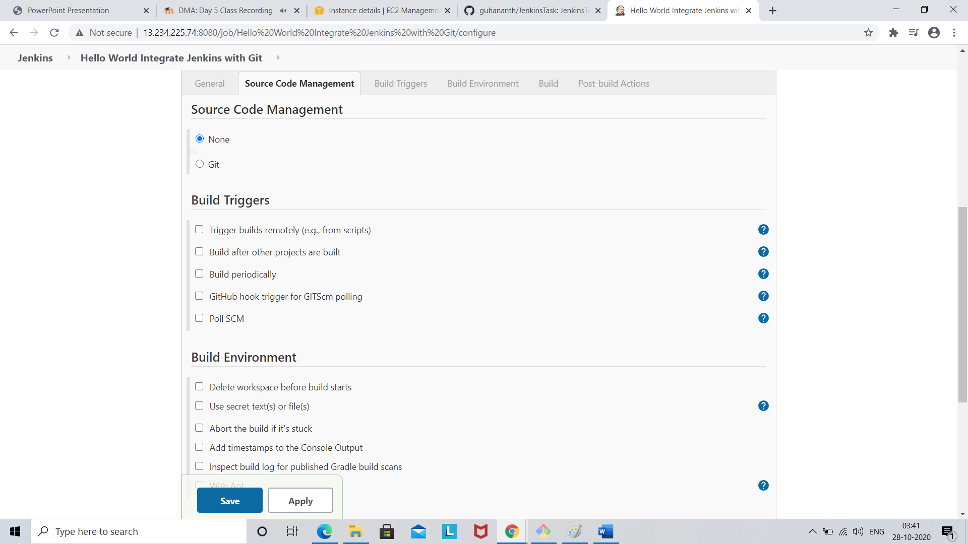

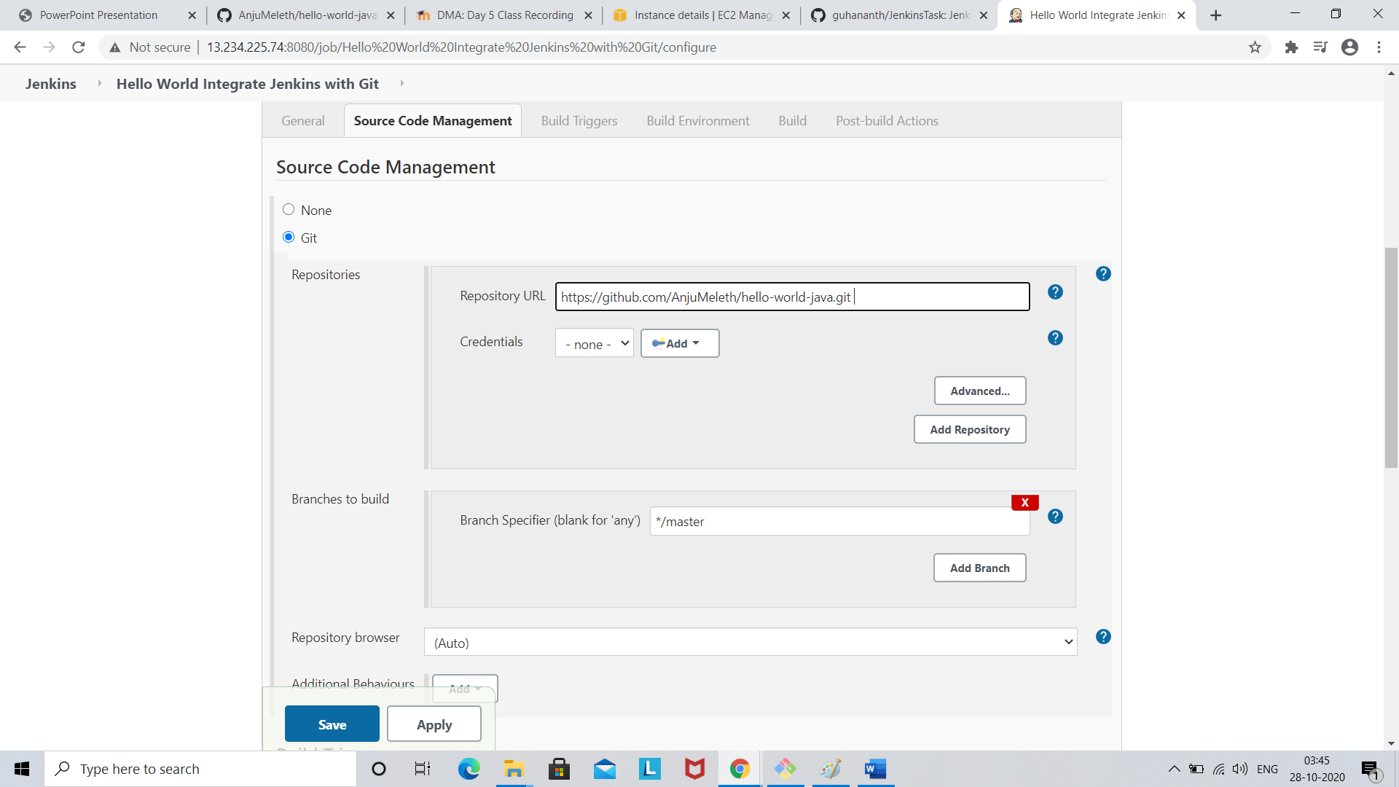

Click build section

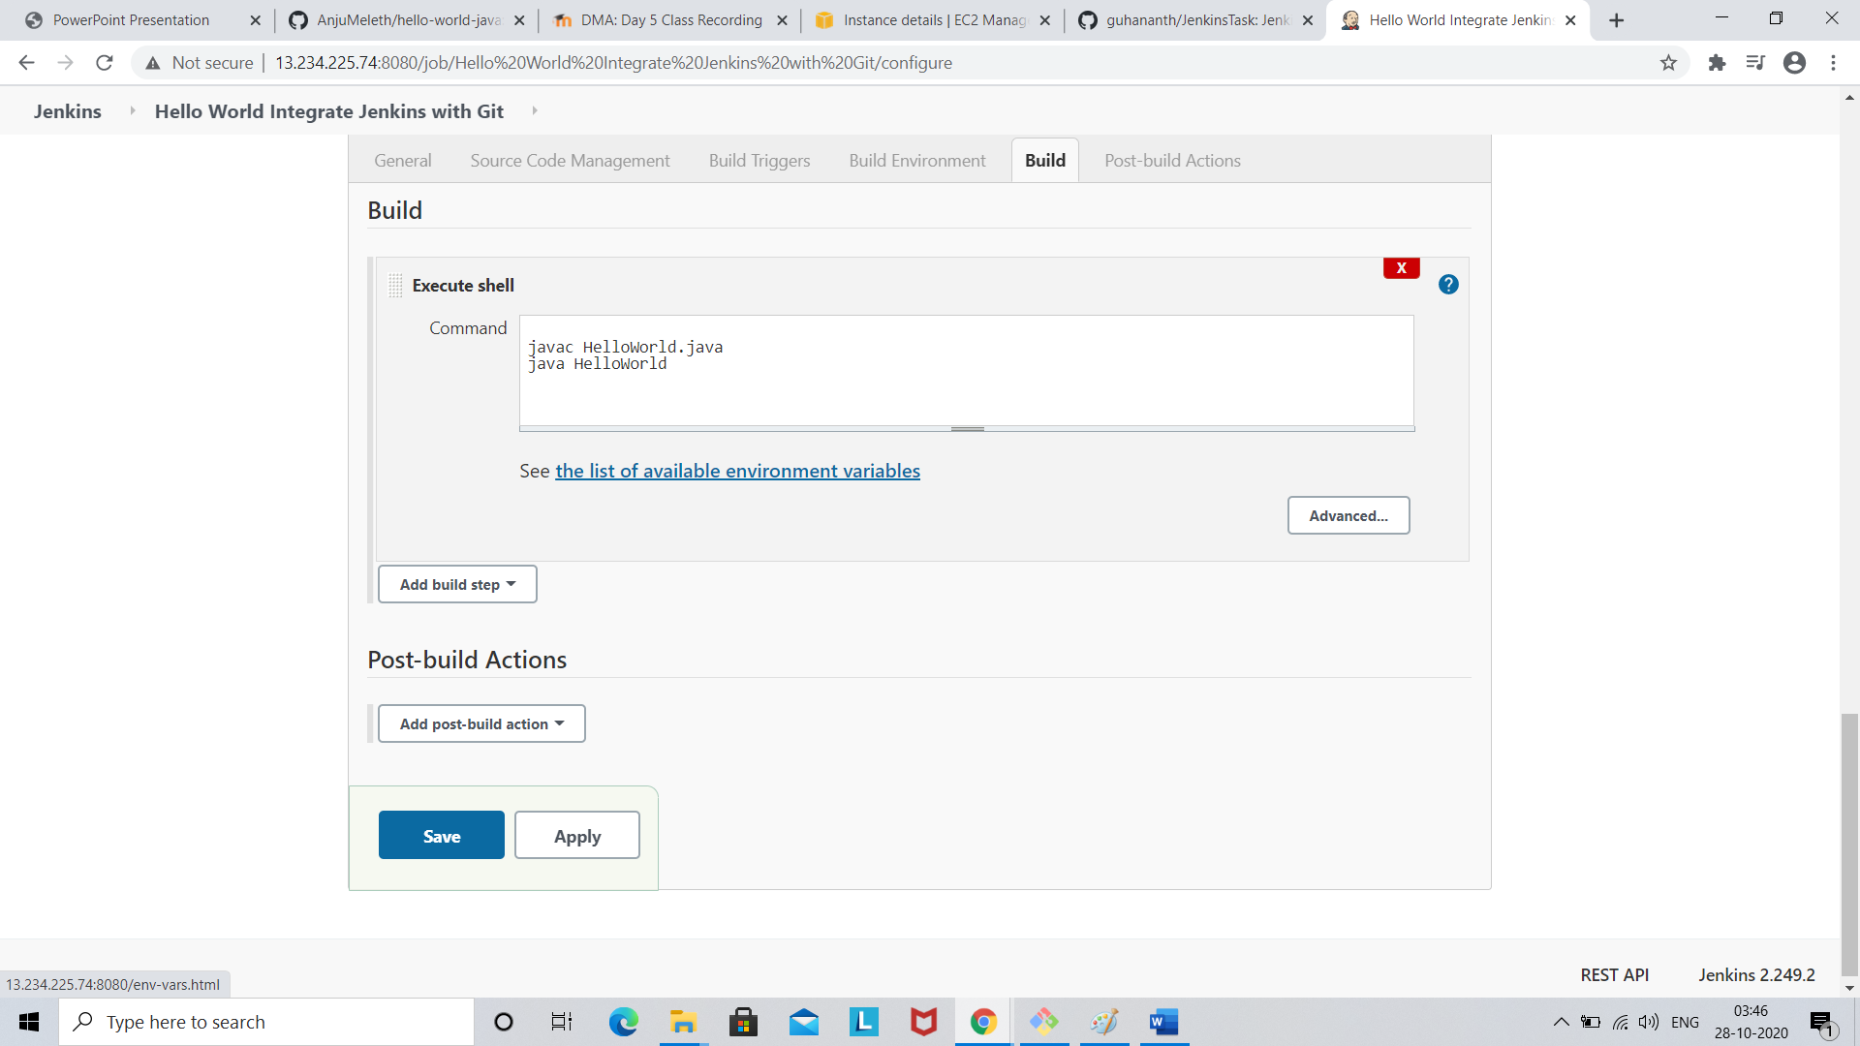

Click save

Click build

